**DESIGN DOCUMENT**

◦ File Name Specification – Name String, Extension of the files:

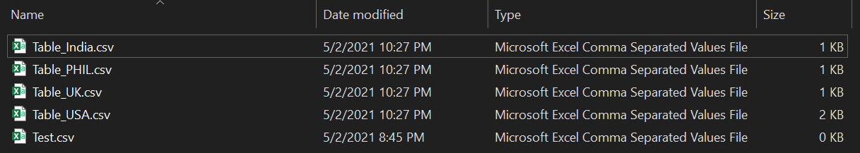

◦ Date and Time format of the File – YYYYMMDD, HHMMSSTT or any other format:



◦ Header Records Layout:



◦ Details Record Layout:



**Technical Assessment: Deliverables**

**1. Create table queries**

IF EXISTS (

SELECT *

FROM INFORMATION_SCHEMA.TABLES

WHERE TABLE_NAME = 'CustomerData'

)

DROP TABLE dbo.CustomerData

CREATE TABLE CustomerData (

[H] VARCHAR(2) NOT NULL

,[Customer Name] VARCHAR(255) NOT NULL

,[Customer ID] VARCHAR(18) NOT NULL

,[Customer Open Date] DATE NOT NULL

,[Last Consulted Date] DATE

,[Vaccination Type] CHAR(5)

,[Doctor Consulted] CHAR(255)

,[State] CHAR(5)

,[Country] CHAR(5)

,[Post Code] INT

,[Date of Birth] DATE

,[Active Customer] CHAR(1)

,PRIMARY KEY ([Customer Name])

)

INSERT INTO CustomerData VALUES ('D','Alex','123457','2010-10-12','2012-10-13','MVD','Paul','SA','USA','12345','06-03-1987','A')

INSERT INTO CustomerData VALUES ('D','John','123458','2010-10-12','2012-10-13','MVD','','NYC','USA','12345','06-03-1987','A')

INSERT INTO CustomerData VALUES ('D','Mathew','123459','2010-10-12','2012-10-13','MVD','Paul','WAS','PHIL','12345','06-03-1987','A')

INSERT INTO CustomerData VALUES ('D','Matt','12345','2010-10-12','2012-10-13','MVD','Paul','SD','USA','12345','06-03-1987','A')

INSERT INTO CustomerData VALUES ('D','Jacob','1256','2010-10-12','2012-10-13','MVD','','ENG','UK','12345','06-03-1987','A')

INSERT INTO CustomerData VALUES ('D','Prashant','125','2010-10-12','2012-10-13','MVD','Paul','TN','India','12345','06-03-1987','A')

INSERT INTO CustomerData VALUES ('D','Vikram','12','2010-10-12','2012-10-13','MVD','','MH','India','12345','06-03-1987','A')

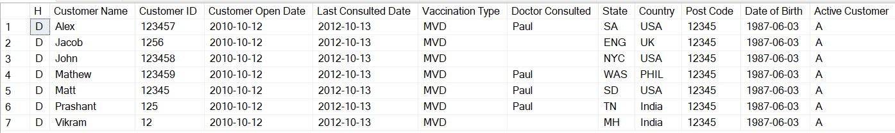

**2. And any script or program which reads the data from files.**

*https://github.com/ar1259/SSISpkg.git*